**Add-ons For Home Assistant/ESP32 Connection**

How To Download Add-ons To Home Assitant

1. Set up your Raspberry Pi as described in the “Home Assistant Installation/User Guide” document and visit [homeassistant.local:8123](http://homeassistant.local:8123/)
2. Click on settings in the left menu of Home Assistant > click Add-ons > click Add-ons store.

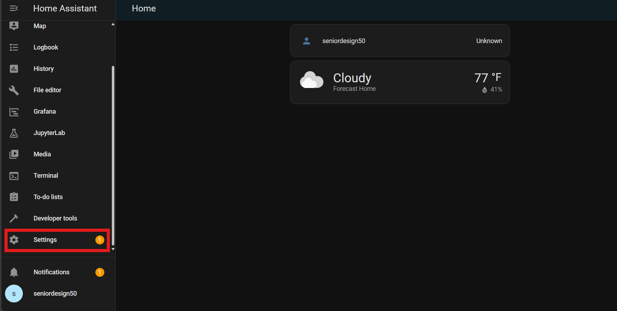

1. Search the add-ons you would like to have on your system and click Install

* You add-ons should look like this once they are installed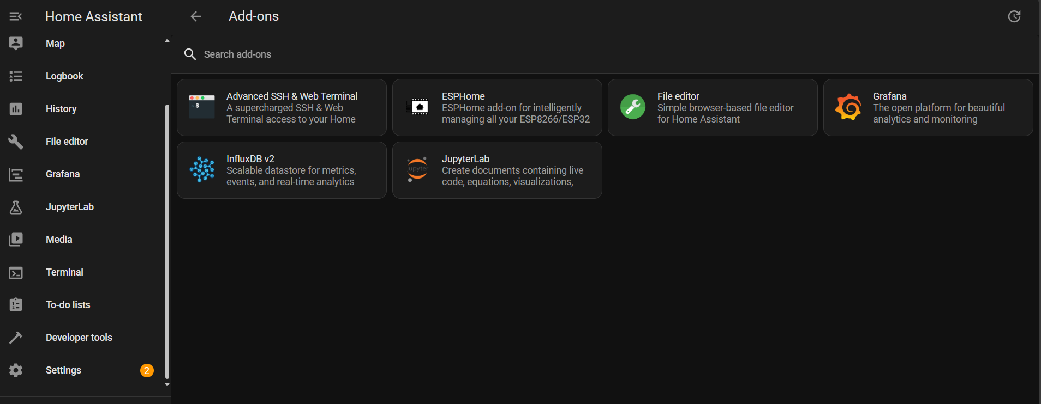

How To Connect ESP32 To Home Assistant

1. Follow the steps in the previous section to install the ESPHome add-on
2. Click on the ESPHome add-on. It will bring you to the window below. They clock on “Open Web Ui” located at the bottom right.

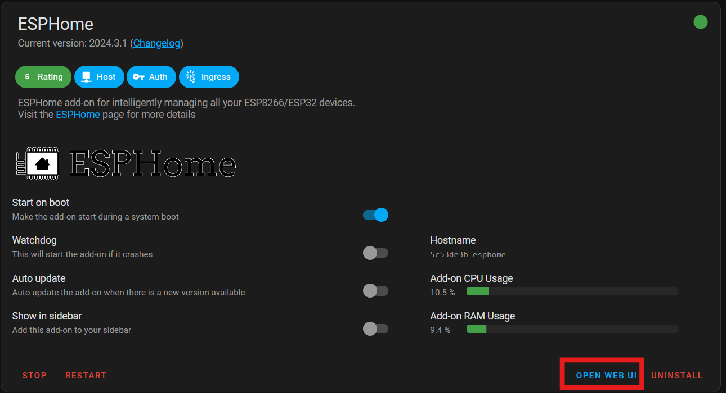

1. Click +New Device located at the bottom right. Name your configuration and select the correct version of the ESP32 device you are going to use for this. Connect this ESP32 to your computer with a USB and click next.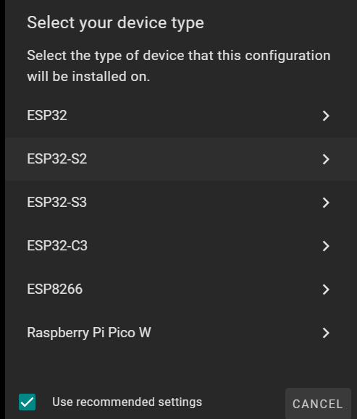
2. Four different ways to connect the ESP32 with ESPHome will pop up. The easiest is the “Plug into this computer option). Click this option and it brings up a screen that says “Preparing Download”. Once this is complete click download and then click the link below it to open ESPHome Web

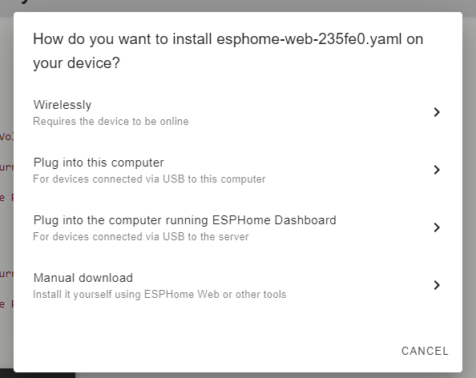

1. Once you have ESPHome web open, click “connect” and then select the port that your ESP32 is connected to. You may need to unplug and replug the device to get it to show up.

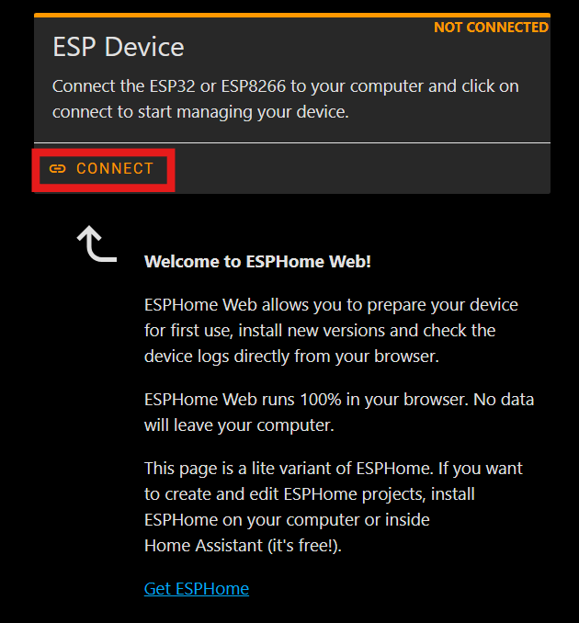

1. Then select ”Prepare Device For First Time Use”. Once this is finished downloading it will prompt you to enter your wifi name and password.
2. Select “Install” and choose the file you downloaded in step 4

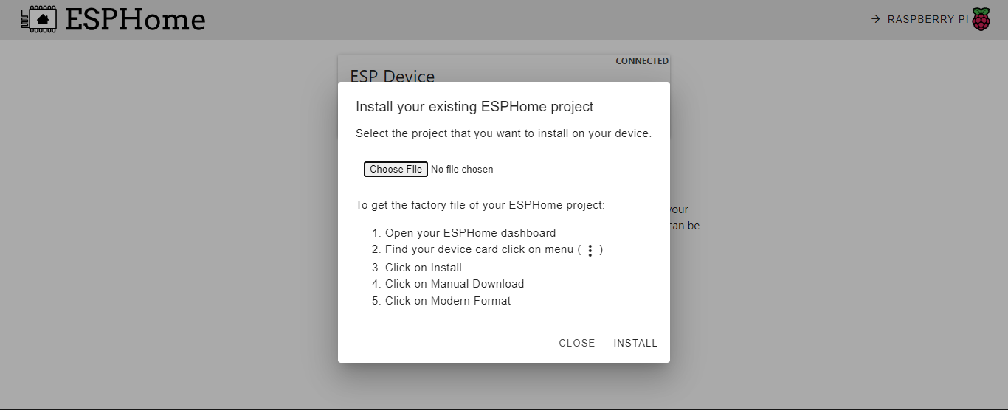

1. Go back to Home Assistant on your browser and select Settings > Devices. Under “Discovered” you should see your ESP32 device. Select if and choose the name/settings you want.

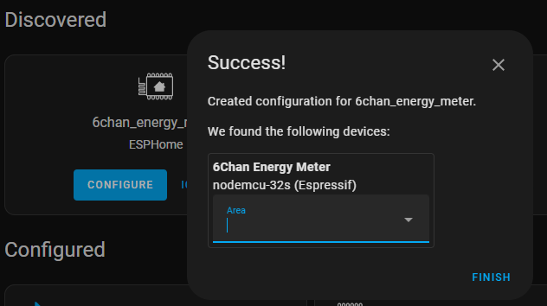

1. Your project should now be online

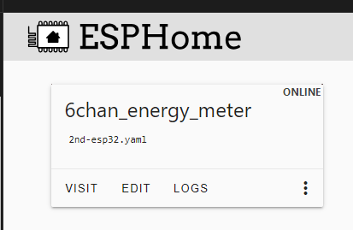

1. If you would like to change the code that your ESP32 is running, click “edit” and then make any changes you want. Once you are done making your changes select instal and then your ESP32 will have that code uploaded to it.